# Case Study

Hypothesis and Recommendations for

Company Growth

Analysis achieved by: Adnan Abed

Address: Warsaw, Poland

Email: [adn.abed@gamil.com](mailto:adn.abed@gamil.com)

Tel.: +48 730 726 134

Date of submission: 20/07/2023

Case Study Details

Objective

Analysis

Data Description

Data Exploration Analysis DEA

Why did EPS drop?

Deep Dive in the Revenue Analysis+

Hypothesis:

Price Analysis:

Revenue Segmentation:

Promotional Impact:

Customer Demographics and Preferences:

Hypotheses and Recommendations

1. Optimize Pricing Strategy (High Business Value)

KIPs for dynamic pricing strategy

KIPs for dynamic segmentation strategy

2. Enhance Marketing and Customer Acquisition Strategies (Medium to High Business Value)

KIPs for Enhancing Marketing and Customer Acquisition

3. Improve Customer Experience and Service Offerings (Medium Business Value)

KIPs for Improve Customer Experience and Service Offerings

Data-Driven Approach:

We have gathered booking data for 2019 and 2023 in this table. These are not full years, but Q1/Q2/Q3 for both years.

## Objective

The main goals of the assessment are to find what has changed and why and provide hypotheses/recommendations for future growth-

1. Investigate what happened with the metric “EPS” (Earn Per Seat). Was there any change in EPS between these two years, and if it is, why?
2. Based on the data, try to make at least 3 more hypotheses/recommendations about increasing sales/revenue and ranking them by business value.

## Analysis

### Data Description

* The data set includes 2846263 records and 52 columns
* No duplicates (Bid is a primary key).
* Essential number of Null values in the column paidon_date (680356 rows), we have to exclude these rows when considering calculation based on date.
* Columns (paygate_code, seller_name,class_name, vehclass_id, status_id, and channel) are all with empty cells. Trip_key has 1035143 empty values.

### Data Exploration Analysis DEA

Let’s calculate the Earn per Seat for years 2019 and 2023 to see the development.

Table 1: Comparing Earn per Seat EPS between 2019 and 2023.

| **Year** | **total_usd** | **total_seats** | **eps** |
| --- | --- | --- | --- |
| 2019 | 16857805.94 | 987923 | 17.06 |
| 2023 | 40853409.64 | 3139188 | 13.01 |

Fig. 1: Comparing Earn per Seat EPS between 2019 and 2023.

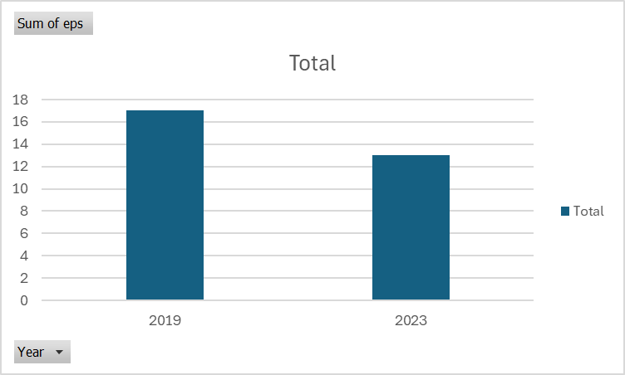

The EPS for 2023 is lower than that of 2019. Let's analyse the reasons why.

### Why did EPS drop?

To determine which factor led to the decrease in earnings per seat (eps) from 2019 to 2023, we can analyze the growth rates of total_usd and seats during this period. If the total_usd increased slower than the seats, it could have contributed to the decrease in eps. Let's test this hypothesis.

Table 2: The growth in Revenue and seat demand

| **Year** | **t_total_usd** | **total_seats** | **total_usd_growth_rate** | **total_seats_growth_rate** | **eps** |
| --- | --- | --- | --- | --- | --- |
| 2019 | 16857805.94 | 987923 | NULL | NULL | 17.06 |
| 2023 | 40853409.64 | 3139188 | 142.34 | 217.76 | 13.01 |

As expected the sum of total_usd grew at a slower rate than the sum of seats causing the drop in EPS for 2023. Next step we will focus on the drop in revenue rather than the growth in demand (Seats).

### Deep Dive into the Revenue Analysis

The observation that the growth in total seats is higher than the growth in total earnings can be attributed to several potential reasons. Here are some possible explanations:

#### Hypothesis:

* **Price Analysis:**
  + Analyse the average price per seat over the years to see if prices have dropped significantly.
* **Revenue Segmentation:**
  + Break down the total earnings by product or service categories to identify if certain segments have experienced a decline in average revenue per seat.
* **Promotional Impact:**
  + Examine the impact of promotions, discounts, and other pricing strategies over time.
* **Customer Demographics and Preferences:**
  + Study changes in customer demographics and preferences to understand if there is a shift towards cheaper or different types of services.

##### Price Analysis:

Let’s analyse the average price per seat over the two years to see if prices have dropped significantly.

Table 3: Comparing Average EPS between 2019 and 2023

| **quarter** | **avg_eps_2019** | **avg_eps_2023** |
| --- | --- | --- |
| Q1 | 17.24 | 13.80 |
| Q2 | 16.91 | 12.95 |
| Q3 | 17.90 | 12.55 |

Fig. 2: Comparing average EPS between 2019 and 2023

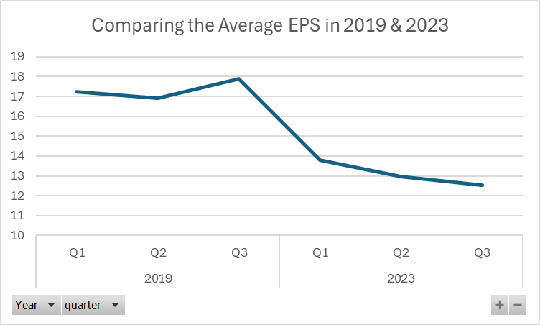

Table 4: Comparing the average quarterly NetPrice between 2019 and 2023.

| **year** | **quarter** | **Average_netprice_usd**  **2019** | **Average_netprice_usd**  **2023** |
| --- | --- | --- | --- |
| 2019 | Q1 | 14.00 | 11.45 |
| 2019 | Q2 | 13.71 | 10.72 |
| 2019 | Q3 | 14.52 | 10.32 |

Fig. 3: Comparing average NetPrice (USD) between 2019 and 2023.

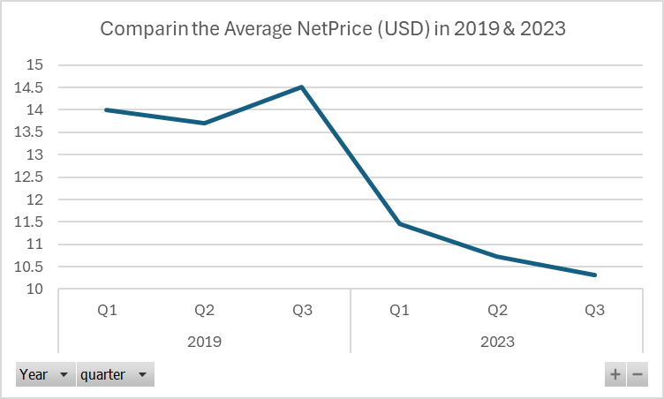

The drop in average EPS was associated with a drop in average Net prices between the two years.

##### Revenue Segmentation:

Break down the total earnings by product or service categories to identify if certain segments have experienced a decline in average revenue per seat. Though we don’t have a lot of data showing the different offerings, we will analyse the available data based on the Class_id.

Table 5: Top 10 classes_id have experienced the highest difference in the average of EPS in 2019 and 2023

| **class_id** | **avg_eps_2019** | **avg_eps_2023** | **diff_avg_eps** |
| --- | --- | --- | --- |
| 1918 | 2178.63 | 13.09 | 2165.54 |
| 1662 | 97.84 | 7.75 | 90.09 |
| 20 | 18.08 | 83.42 | 65.34 |
| 1597 | 78.25 | 25.62 | 52.63 |
| 28 | 21.94 | 57.11 | 35.17 |
| 1320 | 89.44 | 54.59 | 34.85 |
| 2728 | 59.86 | 26.31 | 33.55 |
| 34 | 6.77 | 36.16 | 29.39 |
| 1607 | 5.40 | 29.92 | 24.52 |
| 1155 | 43.35 | 18.84 | 24.51 |

Fig. 4: Table 5: Top 10 classes_id have experienced the highest difference of average EPS in 2019 and 2023

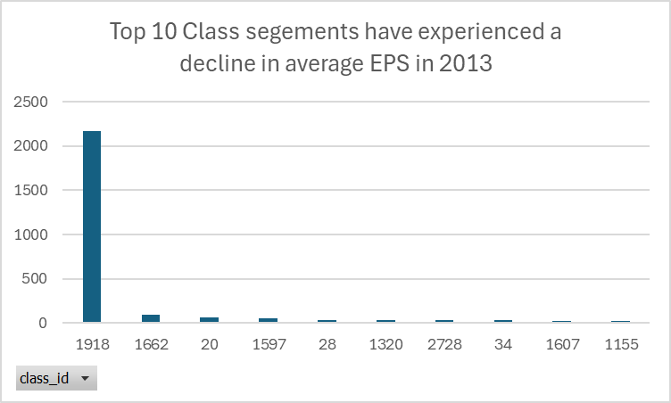

##### Promotional Impact:

Examine the impact of promotions, discounts, and other pricing strategies over time.

In the current phase, we don’t have access to the promotional data to analyse such impact. **Comparative Analysis** would be useful to compare sales and profits before, during, and after promotions.

##### Customer Demographics and Preferences:

Study changes in customer demographics and preferences to understand if there is a shift towards cheaper or different types of services.

Table 6: Top 10 countries with extreme drop in average EPS comparing 2019 and 2023.

| country_id | Country_Name | avg_eps_2019 | avg_eps_2023 | diff_avg_eps |
| --- | --- | --- | --- | --- |
| AZ | Azerbaijan | 57.27 | 11.83 | 45.44 |
| LR | Liberia | 46.08 | 8 | 38.08 |
| ZM | Zambia | 56.47 | 23.24 | 33.23 |
| ME | Montenegro | 39.41 | 12.26 | 27.15 |
| PY | Paraguay | 34.93 | 12.18 | 22.75 |
| GT | Guatemala | 37.07 | 16.14 | 20.93 |
| CV | Cape Verde | 33.22 | 13.18 | 20.04 |
| CR | Costa Rica | 35.28 | 16.57 | 18.71 |
| SV | El Salvador | 28.64 | 10.76 | 17.88 |
| CK | Cook Islands | 27.8 | 10.27 | 17.53 |

Fig. 5: Top 10 countries with the highest drop in EPS between 2019 and 2023.

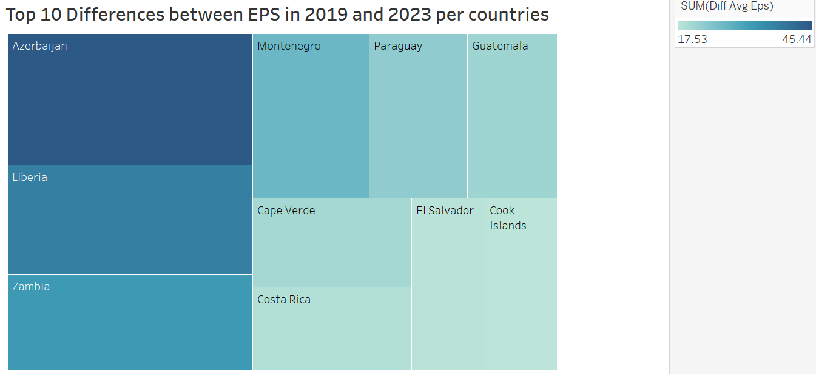

## Hypotheses and Recommendations

Based on the provided data schema and the identified drop in Eran per Seat (EPS) between 2019 and 2023, here are three hypotheses and recommendations for increasing sales and revenue, ranked by business value:

### 1. Optimize Pricing Strategy (High Business Value)

**Hypothesis:** Adjusting the pricing strategy to reflect market demand and competitive positioning can enhance revenue per seat.

**Recommendations:**

* **Dynamic Pricing:** Implement dynamic pricing models that adjust ticket prices based on factors such as demand, time to departure, and competition. For instance, increase prices during peak travel times and offer discounts during off-peak times.
* **Segmentation:** Offer different pricing tiers based on customer segments, such as economy, business, and premium seats, to cater to varying customer preferences and willingness to pay.
* **Promotions and Discounts:** Run targeted promotions and discounts for specific routes or times that typically experience lower occupancy to increase seat utility land overall business performance.

The analysis below provides some insights from 2023 (Q1, Q2, Q3) that might be considered while implementing the new models of pricing.

**! Important:**

* **Statistics Significance** needs to be tested to ensure these differences have not occurred by chance.
* The statistics include the date and time that have been implemented are based on **paidon_date**. That may imply the purchase date and time, not the real travel time.

#### KIPs for dynamic pricing strategy

Table 7: Top 10 percentages of Seat demand per month 2023.

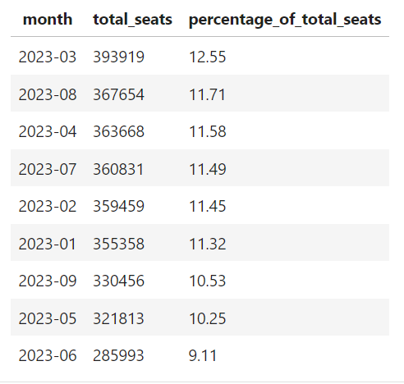

March and August have relatively higher percentages of seat demand compared with other months.

Table 8: Seat demand per day of the week (Q1, Q2, Q3) 2023.

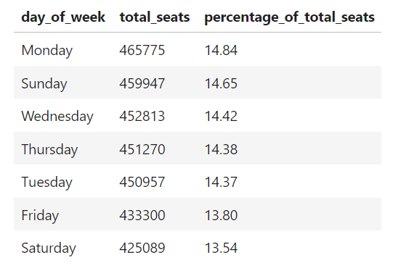

Monday and Sunday have relatively higher percentages of seat demand compared with other days of the week (2023).

Table 9: Seat demand per hour of the day (Q1, Q2, Q3) 2023.

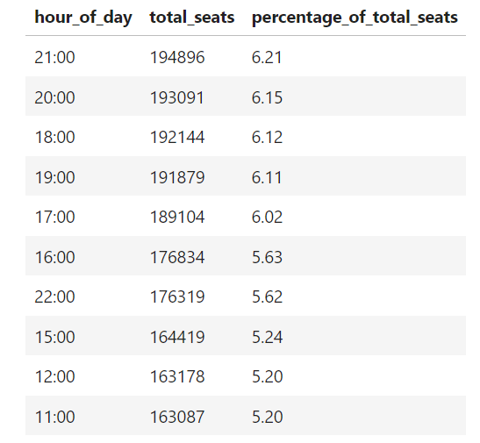

The hours 21:00 and 20:00 are the most relevant time for booking.

#### KIPs for dynamic segmentation strategy

Table 10: Top 10 classes in terms of Total revenue generated in (q1, Q2, Q3) 2023.

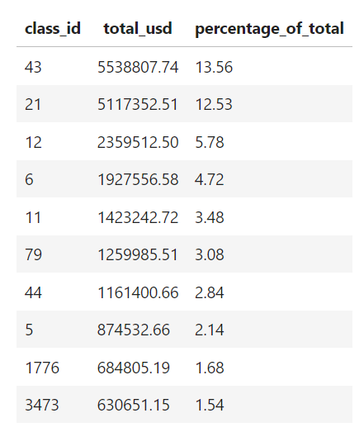

Table 11: Top 10 countries in terms of Total revenue generated in (q1, Q2, Q3) 2023.

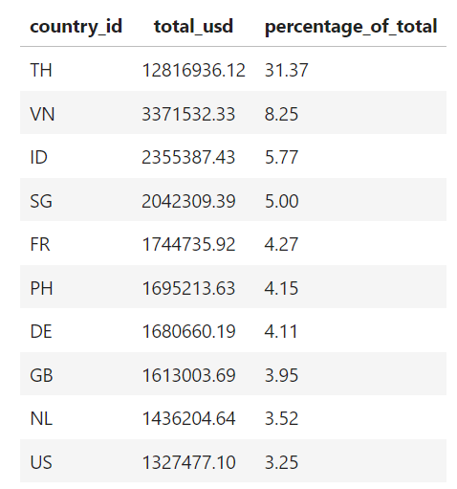

### 2. Enhance Marketing and Customer Acquisition Strategies (Medium to High Business Value)

**Hypothesis:** Improved marketing and targeted customer acquisition strategies can increase overall sales volume and revenue.

**Recommendations:**

* **Targeted Advertising:** Utilize data analytics to identify high-value customer segments and create targeted advertising campaigns through digital marketing channels, including social media, search engines, and email marketing.

#### KIPs for Enhancing Marketing and Customer Acquisition

Table 12: Top 10 countries in terms of Total revenue generated in (q1, Q2, Q3) 2023.



* **Loyalty Programs:** Develop and promote loyalty programs to encourage repeat bookings. Offer points or discounts for frequent travellers, which can increase customer retention and lifetime value.
  + Validating KPIs

Table 13: Top 10 countries in terms of Total revenue generated in (q1, Q2, Q3) 2023.

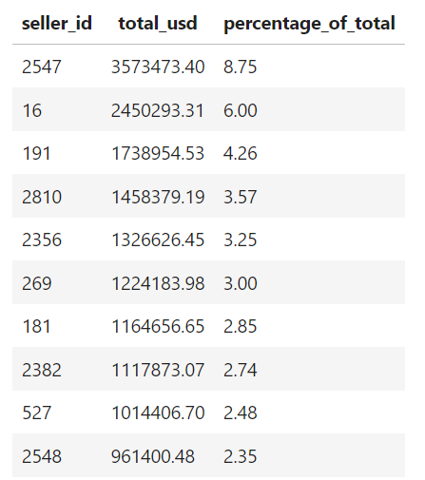

* **Partnerships:** Partner with travel agencies, corporate clients, and other relevant businesses to offer bundled deals and increase sales through their networks.
  + Validating KPIs

Table 14: Top agents/partners in terms of Total revenue generated in (q1, Q2, Q3) 2023.

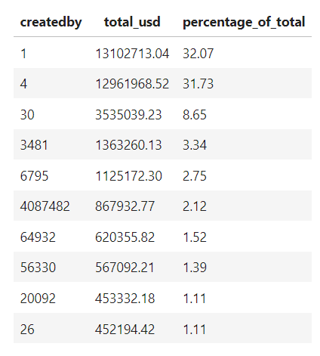

### 3. Improve Customer Experience and Service Offerings (Medium Business Value)

**Hypothesis:** Enhancing the overall customer experience and expanding service offerings can lead to increased customer satisfaction, repeat business, and higher revenue per seat.

**Recommendations**:

* **Customer Feedback:** Regularly gather and analyze customer feedback to identify areas for improvement. Implement changes based on this feedback to enhance the overall travel experience.
* **Additional Services:** Introduce value-added services such as in-transit entertainment, Wi-Fi, meal options, and comfortable seating arrangements. Offer these as premium services to increase revenue per seat.
* **Ease of Booking:** Simplify the booking process on the website and mobile apps. Ensure a user-friendly interface and offer multiple payment options to cater to a broader audience.

#### KIPs for Improve Customer Experience and Service Offerings

Table 15: Top user agents have been used based on of Total revenue generated in (q1, Q2, Q3) 2023.

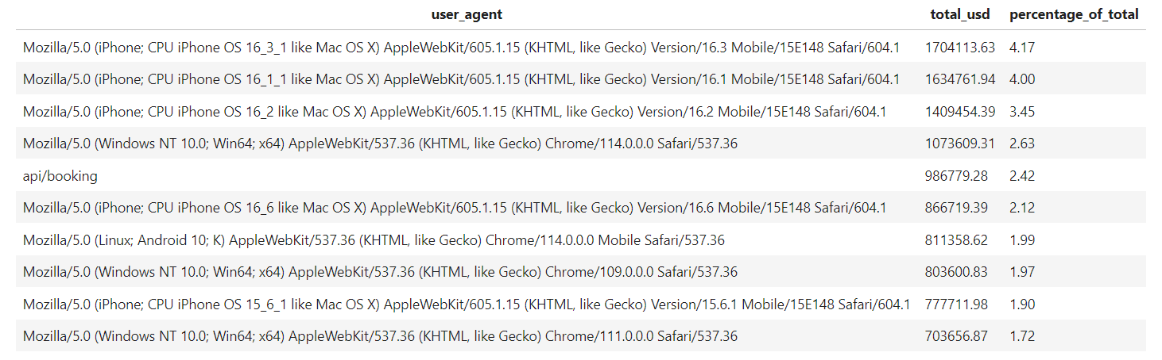

Table 16: Top landing page performance in terms of Total revenue generated in (q1, Q2, Q3) 2023.

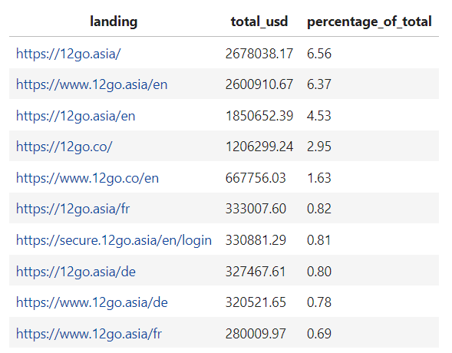

### 

### Data-Driven Approach:

To validate these hypotheses and implement the recommendations effectively, consider the following steps:

1. **Data Analysis:** Conduct additional detailed data analysis to understand customer behaviour, booking patterns, and price sensitivity. Use historical data from 2019 and 2023 to identify trends and insights.
2. **A/B Testing:** Implement A/B testing for dynamic pricing models, marketing campaigns, and service enhancements to measure their impact on sales and revenue.
3. **Customer Surveys:** Perform surveys and gather qualitative data to supplement quantitative analysis. This can provide deeper insights into customer preferences and satisfaction levels.

By implementing these hypotheses and recommendations, the company can increase its sales and revenue, thereby improving the Eran per Seat (eps) and overall business performance.

## Limitations

Due to time constraints, this analysis represents a preliminary examination of the data, which can be further validated and expanded to consider various variables included in the data set.